Sunday | Monday | Tuesday | Wednesday | Thursday | Friday | Saturday
 |  |  |  |  | Make a yummy breakfast parfait with yogurt, fresh fruit and granola. | Create a fun placemat to use at the table during meals.
Pumpkins are a great source of antioxidants. Make yummy pumpkin bread as a family. | Make a family meal together. Have each person choose what they would like to eat, and prepare in the kitchen. | Move in opposites- fast/slow, up/down, near/far, big/small. | Go to your local library and check out, Be Good to Your Body by Roz Fulcher and make a snack from the book.  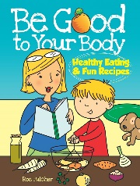 | Go outside for a walk and look at different shapes. Move your body to create the shapes you see. | Use different household items to make drums. Play the drums and move to the beat. You can even create a fun song to go with it. | Place three different foods on a plate. Ask your child to describe how each food tastes, smells, looks and feels like.
Make a set of cards with numbers on them. Have everyone choose a card and the number they selected is the number of body movements you have to make (stretch to the ceiling, march in place, touch your toes, etc.). | Choose a healthy food that begins with the letter ‘N’. Try the food together as a family. | Place plastic or real vegetables in a bag. Close your eyes and reach in the bag to describe and guess the vegetable. Add vegetables of different sizes and textures. | Place a bunch of washcloths across the floor, and try jumping from one to the next without touching the floor. | Use magazines and find fruits and vegetables that are orange and red and create a harvest basket. | Have someone name a color and then create a movement to match that color. | Guess the Fruit! Have one person describe the fruit they choose and everyone try to guess.
Make funny face pizzas using whole grain bread. | Do some outdoor chores as a family. Reach, push, pull and bend. | Go to your local library and check out the book, The Berenstain Bears and Too Much Junk Food, by Stan and Jan Berenstain.  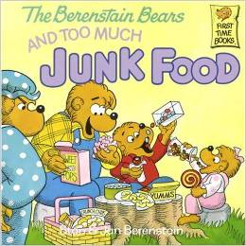 | Add a whole grain food to your snack or meal. | Practice balancing a paper plate on your head and walk across the room. Time yourself to see who is able to reach the other end the quickest. | Sit down and have a family meal together without the TV, phones or computers. | Mindful Minute  Close your eyes and take a deep breath and let your body relax.
Practice your jumping skills. Bend your knees and push off the floor, See how high and far can you jump. | Play “I spy” outdoors, the person has to make a guess by running to the object they think it is. | March in place for one minute without stopping. Talk to your family about what happens to your heart. | Create a sorting game, by having your child sort canned fruits or vegetables, by color or size. | Add your favorite fruit to your water and talk about the taste. | Try fresh vegetables with hummus dip. | Choose your favorite physical activity from November and repeat.

