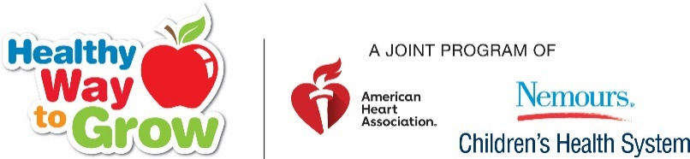
(
You have prioritized Health & Wellness Goals!
You have trained staff & improved curriculum!!
You have implemented your goals throughout your program!!!

It’s time to recognize you for your efforts!!!
Center Recognition Webinar
Please join us on Tuesday Nov. 12th
12:00 EST/11:00 CST
An Skype invite is coming to your inbox!
Learn about the steps for center recognition, what to include with your application, how to document and label attachments, submitting electronically or hard copy, and more. Even if you are not sure you are ready to apply, please join us and learn more.

